How to push complete floder or file to github

**Step1**:

Create a repository name in github

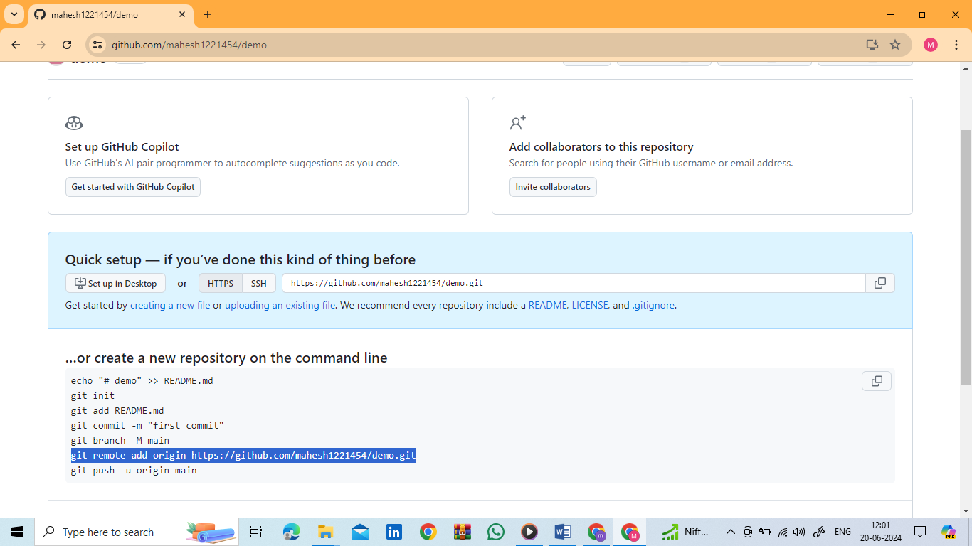

Copy the above command in the gui of github

**Step2:**

Open the gitbash server in ur loptop

**Step3:**

In gitbash goto the file path

**Step4:**

git init

**Step5:**

check the file status, ( the file name visible in red colour because it in untraced files)

$ git status

**Step6:**

(to sending the files into staging area)

$ git add . (or) git add file_name

**Step7:**

once check the file colour ( now it is visible in green )

$ git status

**Step8:**

git commit –m “give some name”

**Step9:**

paste the command line ,what ever we copy from github in the begning.

**Step10**:

Check the github repository files.